MICROCONTROLLER BASED WATER LEVEL CONTROLLER

BLOCK DIAGRAM

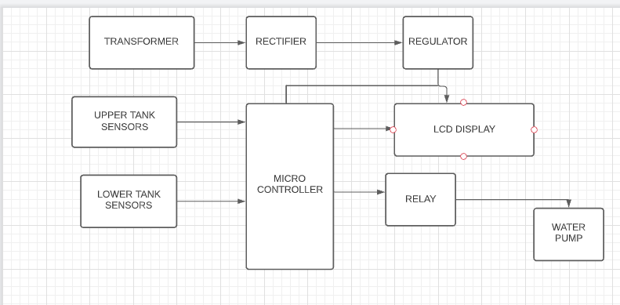

INTRODUCTION

 In most houses, water is first stored in an underground tank (UGT) and from there it is pumped up to the overhead tank (OHT) located on the roof. People generally switch on the pump when their taps go dry and switch off the pump when the overhead tank starts overflowing. This results in the unnecessary wastage and sometimes non-availability of water in the case of emergency.

The Water Level Controller System is an Electronic Equipment which when electrically connected to the starter of any given Pump-set motor will control the operation of the pumpset depending upon the water level in the Source and Destination Storage Tanks.

The **MBACWPMLI** uses ultrasonic sensor installed at the top of a tank to send and receive sound waves, and the time taken is converted to distance by the microcontroller to give corresponding digital outputs which turns ON LEDs that indicate the level of water in the storage tank.